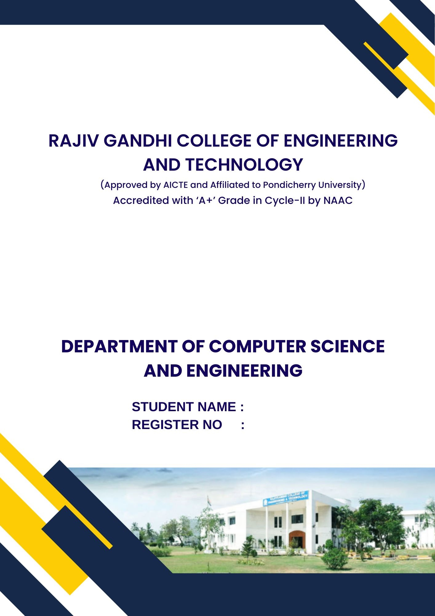
GENERAL PROFICIENCY - II (HS P65)


MOHAMED B SIRAJUDDEEN
22TD0053
RAJIV GANDHI COLLEGE OF ENGINEERING
AND TECHNOLOGY
(Approved by AICTE and Affiliated to Pondicherry University)
Accredited with ‘A+’ Grade in Cycle-II by NAAC
Pondy – Cuddalore Main Road, Kirumampakkam, Puducherry - 607403

DEPARTMENT OF COMPUTER SCIENCE
AND ENGINEERING



Record Note Book

Name : MOHAMED B SIRAJUDDEEN
Register No. : 22TD0053
Course : B. Tech (CSE)
Year / Semester : Y3/ S6
Subject & Code : GENERAL PROFICIENCY - II (HS P65)

RAJIV GANDHI COLLEGE OF ENGINEERING
AND TECHNOLOGY
(Approved by AICTE and Affiliated to Pondicherry University)
Accredited with ‘A+’ Grade in Cycle-II by NAAC
Pondy – Cuddalore Main Road, Kirumampakkam, Puducherry - 607403



DEPARTMENT OF COMPUTER SCIENCE AND ENGINEERING

BONAFIDE CERTIFICATE

This is to certify that the Bonafide record of practical work done by Mr. MOHAMED B SIRAJUDDEEN, Reg. No. 22TD0053 pursuing Third year B.Tech. of Department of Computer Science and Engineering in GENERAL PROFICIENCY - II (HS P65) during the Academic Year 2024-2025.
Faculty In-charge | Head of the Department

